ARM templates:

* ARM template is a block of code that defines the infrastructure and configuration for your project.
* Components of ARM templates.

Parameters

Functions

Variables

Resources

* If we create ant resource in azure portal automatically template will be generated.

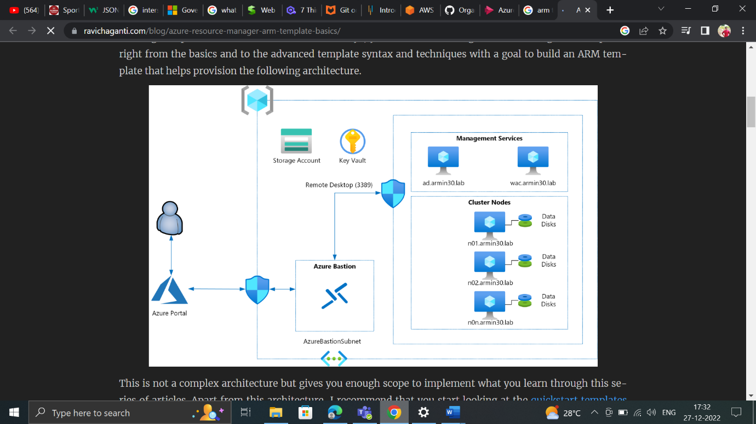

* If we create any resource in azure portal and if we explore the template, then we get the code is in JSON format.

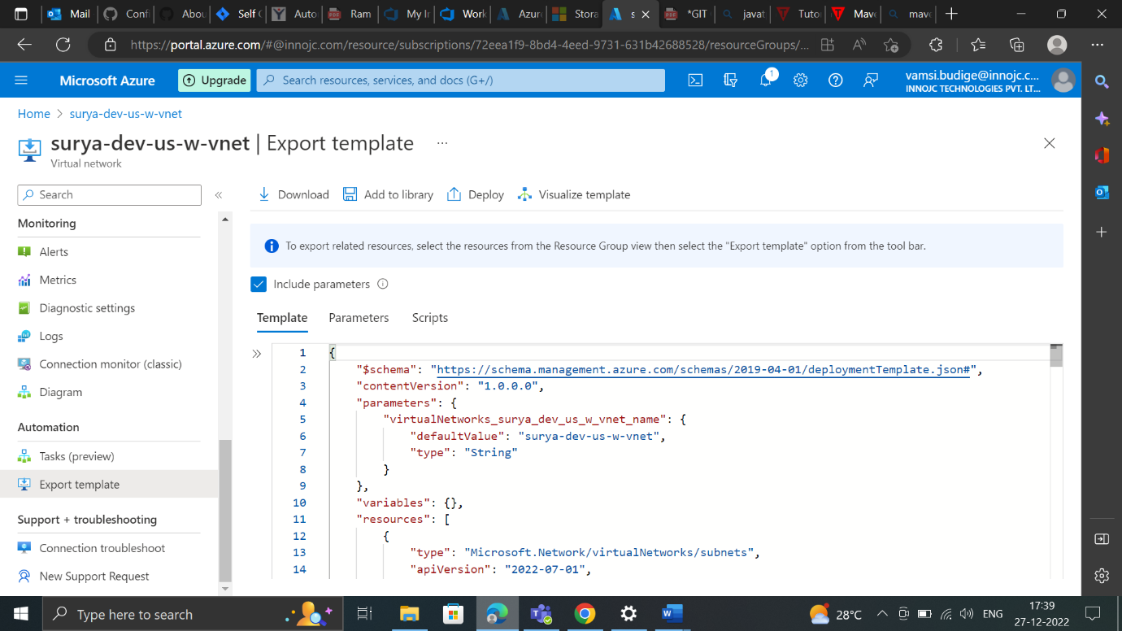

Maven tool:

* Maven is a project management and comprehension tool that provides developers a complete build lifecycle framework.
* What ever the code in java, .net that will be changed into some package i.e., system understandable language this process is build preparation.
* For java we are using maven build tool.
* For .net we are using ant build tool.
* We are creating the pom.xml file. So antifactory and artifacts data is present in pom.xml file.
* We must cross check whether we have exact path or not.
* We can see path in pom.xml file and we must check in artifacts.
* Once if we prepare build, we must send to dev, test, stage, and production team. (Same build)
* POM stands for project object model it is fundamental unit of work in maven.it is an xml file that resides in the base directory of the project.
* The pom.xml file contains information of project and configuration information for the maven to build the project such as dependencies, build directory, source directory, test source directory, plugin, goals etc.
* Maven architecture:
* Graphical user interface

  Description automatically generated